HR Employee Attrition Dashboard using Power BI

Abstract
The HR Employee Attrition Dashboard is developed using Microsoft Power BI to analyze employee attrition and workforce trends. The dashboard provides an interactive view of employee data, helping HR professionals understand attrition patterns based on department, age, gender, job role, salary, and other factors. It supports data-driven decision-making for improving employee retention.

Introduction
Employee attrition is a major concern for organizations because it increases recruitment costs and affects productivity. Power BI helps convert raw HR data into interactive visualizations, making it easier to identify the reasons behind employee turnover. This dashboard presents key HR metrics in a simple and user-friendly format.

Objective
- To analyze employee attrition using Power BI.
- To create an interactive HR dashboard.
- To identify departments and job roles with higher attrition.
- To support HR teams in making better employee retention strategies.

Dataset Description
The dataset contains employee information such as Age, Gender, Department, Job Role, Education, Monthly Income, Years at Company, Overtime, and Attrition Status. The data was cleaned and transformed using Power Query before creating the dashboard.

Dashboard Features
The dashboard includes:
- KPI Cards showing Total Employees, Average Age, Employee left, and Attrition Rate, Average Salary.
- Bar Charts for Department-wise and Job Role-wise Attrition.
- Pie/Donut Chart for Gender-wise Attrition.
- Line/Column Charts for Age Group and Income Analysis.
- Interactive Slicers for filtering by Department, Gender, Education, and Job Role.

Results
The dashboard provides a clear overview of employee attrition trends. HR managers can easily identify departments with high attrition, compare employee demographics, and analyze important workforce metrics through interactive visualizations.
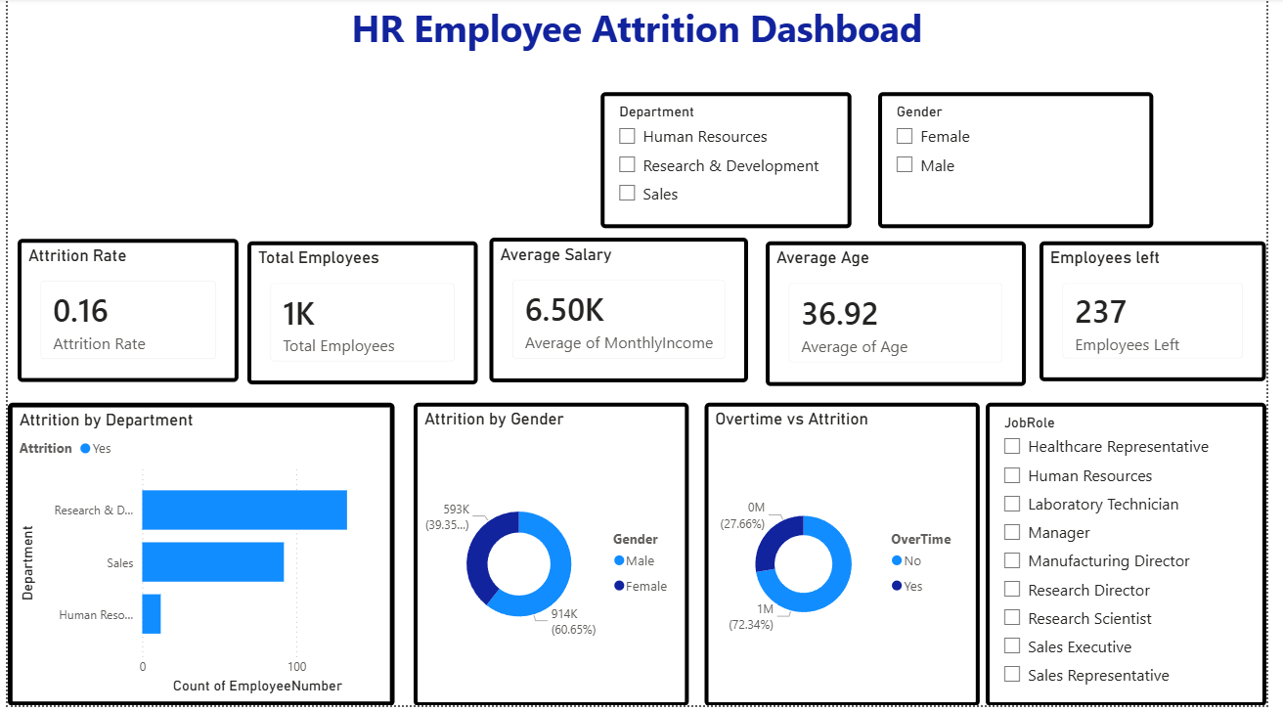
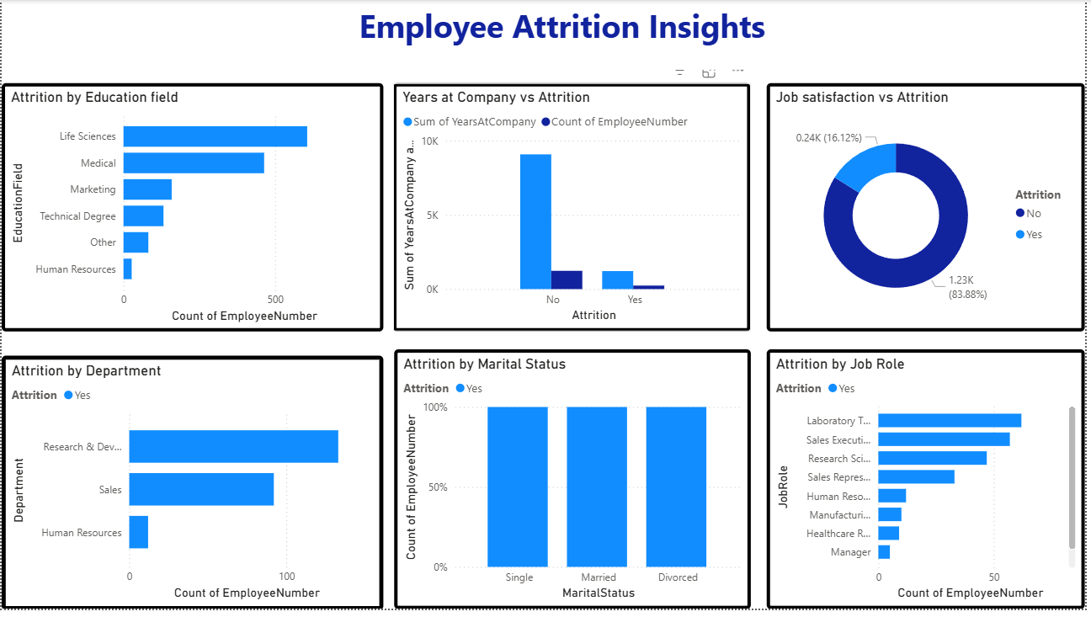

Conclusion
The HR Employee Attrition Dashboard successfully converts employee data into meaningful insights. It enables HR teams to monitor attrition, identify problem areas, and take proactive measures to improve employee retention.

Future Scope

- Connect the dashboard with a live HR database.
- Add predictive analytics for employee attrition.
- Include real-time HR metrics and automated reporting.
- Publish the dashboard on Power BI Service for organization-wide access.

